Instruction Sheet:

To Move:

Use the WSAD to walk and turn. Hold down the right mouse button to run. Use SPACE button to jump. You can jump further while running.

Exhaustion Bar:

The exhaustion BAR is at the top left corner. It indicates your exhaustion value. When running, you will become exhausted. You can neither run nor jump without enough energy. Make sure to monitor your exhaustion meter when adventuring.

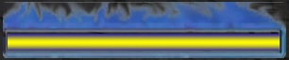

Object Interaction:

To pick up an object go to the object, and left click with your mouse .The cursor on the screen changes to a hand when you get close to an object that you can pick up.

Flares:

By picking up a lantern or a flare and tossing them into oil spills or boxes of explosives ignites the fire and traps the zombies.

If the size of the object is considerably big you can push the object.

Zombie Attack:

When attacked by Zombies, use the Left Click to inject yourself with the antidote before the skull bar runs out to cure yourself.

Injection:

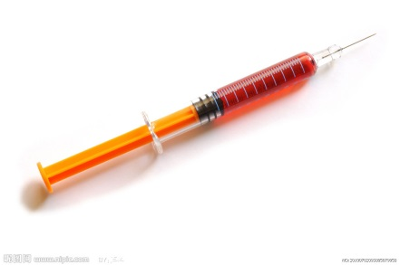

Skull bar:

C:\Users\Lakshmi\Desktop\skull.jpg

When injected, you stay immune to all the zombie attacks. This immunity will only last for a short time, indicated by the glow around the player.

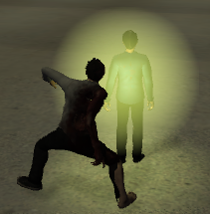

If the exhaustion value is greater than half you can shun all the zombies by clicking the left and right mouse button together.

Objects can be tossed to distract the zombies.

Flares and Flash Bangs

Flares are red tubular objects, that when thrown in a puddle of oil, they will ignite a fire to block zombie’s paths.

Flash Bangs are green grenade like objects that when thrown, will detonate upon collision with an object. Any zombie caught in the blast radius will be stunned for 10 seconds and be unable to chase, see, or attack the player.